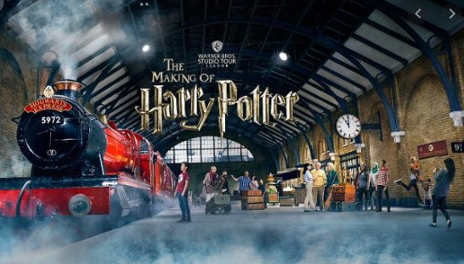
03.02.20
Dear Parents

As part of our ‘Potions’ topic after half term, we are delighted to inform you that we will be visiting Harry Potter World at Warner Bros Studios. We will be using Harry Potter and the Philosopher’s Stone as the inspiration for most of our English work next half term and we think that a visit to Harry Potter World will be an incredibly exciting way to bring that learning to life!

Harry Potter World is a very popular venue for school visits. Tickets for schools are offered at a heavily discounted rate, but numbers are limited and the venue can be fully booked as much as a year in advance. We have been able to secure a visit on Friday 6th March, but the only slot that the venue could offer us is in the afternoon. This means that we will be leaving school at around 12pm and not getting back until approximately 8:30pm (dependant on traffic).

To avoid the children needing two packed lunches where possible, we are happy to offer a free school dinner to any child who would like one for lunch on the day of the trip. Children will need to bring a ‘packed tea’ to be eaten at Harry Potter World in the evening. Children are of course welcome to bring a packed lunch for both meals if they wish.

The cost of this visit will be £25.00, which includes a tour of the studios, a workshop and the cost of the coach. We realise that this is a substantial amount, but it is an excellent visit and we feel that the children will have a fantastic experience. Payments will be need to made online via our scopay system.

We will allow the children to visit the shop whilst on the visit, but we would like to request that you look on the website with your child prior to the visit so that they know what they plan to buy before they get there. This will reduce the amount of wasted time browsing in the shop when we are there. Please ensure any money is in a named envelope as we will collect it before we go, to ensure it is kept safe until the children need it.
https://shop.wbstudiotour.co.uk/

Please return the consent slip below and return to school as soon as possible. If you are able to accompany us on the trip, please let us know. Further reminders will be sent out nearer the time.

Many thanks

Mrs G Smallwood and Mr S Ewins

Harry Potter Studios

I give consent for my child _________________________ in class ______________

to attend the trip to Harry Potter Studios on Friday 6th March.

I will require a free hot lunch for my child on this day

I will supply a packed tea for my child to have in the evening

I will supply two packed meals for my child

(please tick as appropriate)

I have paid £25 online

