Year 4 – week beginning 6th April
Reading | - Keep reading for at least twenty minutes each day – if you have your Reading Diary at home fill that in too!  - Choose an activity each day from the reading rainbow activities
Spelling | 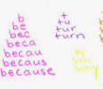  - How many words can you find that end with ‘-ssion’? E.g. session  Make a list and then learn to spell 5 of them using Look, Say, Cover, Write, Check or pyramid writing  Get an adult to test you  - Use Purple Mash to dos to practice spelling
Writing | 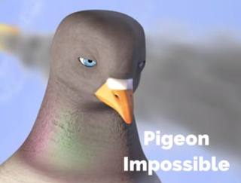  - Watch the animation ‘Pigeon Impossible’ - https://www.literacyshed.com/pigeon-impossible.html  - Make a comic strip to show the events that took place in the animation (comic strip templates have been uploaded to the Year 4 page of the school website, or you can draw your own)  - Draft a newspaper report about the events. Don’t forget to include:  - A headline that uses a pun, rhyme or alliteration  - A subtitle which gives a bit more information about what the report is about  - The reporter’s name  - An introductory paragraph containing the 5Ws (who, what, where, when, why)  - Paragraphs detailing the main events in chronological order  - Pictures with captions  - Quotes from eyewitnesses  - Publish your newspaper report in your best handwriting
Maths | - Go to the Year 4 sections of the White Rose website: https://whiterosemaths.com/homelearning/year-4/  Complete the lessons and activities for week 1 – recognising tenths and hundredths  - Spend at least fifteen minutes a day on Times Tables Rock stars  Challenge someone new in the year group and a teacher you’ve never challenged before!  - Complete the MyMaths tasks that have been set for you at www.mymaths.co.uk
Curriculum Task | - Continuing our Science focus on Living things and their habitats - watch the clip about Levon Biss: http://microsculpture.net and explore some of the images of his work on the website.  - Create your own larger scale observational drawing of a common British insects. Choose an image of an insect and follow the instructions on how to up-scale the image (instructions have been uploaded to the Year 4 page of the school website). Do each step slowly, being sure to include the details. You could add some colour with watercolour paints!

